**Introduction to Signals and Modulation**

1. **Instructions**

Work in groups of four. You have two supervised laboratory sessions to work on the practical - you will need to continue work on the laboratory through out the following week, such that you are in a position to be able commence work on the 'Sinusoidal Signal Demodulation' section for the next supervised laboratory. The reflection section of the laboratory is a group reflection. Outstanding sections of the laboratory must be completed in your own time.

The completed laboratory should be uploaded into the course's weekly upload system in pdf format. You should print out the [Marking Scheme](http://staffweb.cms.gre.ac.uk/~sp02/Signals&Modulation/MarkingScheme.htm) and bring a print out of your completed laboratory to next laboratory session for marking.

1. **Objectives**
   * To introduce signal classification and metrics.
   * To introduce the concept of time and frequency domains.
   * To introduce the concept of modulation and Frequency Division Multiplexing (FDM).
2. **Apparatus**
   * Audacity Software
   * Cables and Connectors: -  One 50 Ω BNC terminated coaxial cable. Two BNC to crocodile clips leads. One BNC T piece connector. One 3.5 mm audio plug to BNC cable.
   * 7 meter length of wire, 1 meter length of wire, 1 Germanium Diode, 1 100 pF 2.54 mm Pitch Ceramic Capacitor RC, Terminal Block.
   * Headphones
   * Farun KLS 150 - CB speaker
   * Keithley 3390 50 MHz Arbitrary Waveform Generator
   * Pico Scope - 3206
3. **Introduction**

All communication systems use hierarchical protocols. A communication protocol formally describes each layer of it's hierarchy, layer interactions, message formats and the rules for exchanging of those messages. For example, protocols may include signalling, authentication, error detection and correction, syntax, semantics, and synchronisation of communication. Protocols can be implemented by hardware, software, or a combination of both.

There are numerous communication protocols, with new protocols continually emerging with each advancement of technology. Current common examples include Asynchronous Transfer Mode (ATM), Carrier Sense Multiple Access / Collision Avoidance (CSAMA/CA), Digital Audio Broadcasting (DAB),  Digital Radio Mondiale ([DRM](http://www.drm.org/)) General Packet Radio Service (GPRS), Transmission Control Protocol / Internet Protocol (TCP/IP) and Universal Mobile Telecommunications System (UMTS).

Protocols can be classified into two categories:-

* + Proprietary Networks - Systems designed by a specific vendor, and protected by patent. e.g. Data Highway, Genius Bus and Modbus
  + Open Networks - Are industry agreed common network standards to provide multi-vendor interoperability.

The Institute of Electrical and Electronics Engineers ([IEEE](http://www.ieee.org/index.html)) manage open network standards to ensure compatibility between networking devices and technologies manufactured by different manufactures. The [IEEE standards](http://ieeexplore.ieee.org/xpl/standards.jsp) are organised by number, for example the 400 series covers power, while the 100 series covers testing. The 802 series covers networking, examples are:-

* + - 802.1 Internetworking
    - 802.2 Logical Link Control (LLC)
    - 802.3 Media Access Control (MAC)
    - 802.4 Token Bus Networks
    - 802.5 Token Ring Networks
    - 802.6 Metropolitan Area Network (MAN)
    - 802.7 Broadband Local Area Networks
    - 802.8 Fibre Optic Technology
    - 802.9 Integrated Voice and Data Networks
    - 802.11 Wireless networking
    - 802.12 100 Mbps technologies
    - 802.15 Wireless Personal Area Network (PAN)
    - 802.16 Wireless Broadband
    - 802.20 Mobile Broadband Wireless Access (MBWA)
    - 802.21 Media Independent Handover (MIH)
    - 802.22 Wireless Regional Area Network (WRAN)

In all communication protocols, the lowest layer is the physical layer. Governments and international companies are dedicated to the research and development of signalling, as this is determined by the laws of physics which ultimately limits the rate at which information can be transferred. The higher layers of a protocol are determined by human innovation.

**Signal Classification**

|  |  |  |
| --- | --- | --- |
| **Continuous / Discrete** Signals can be continuous in time and / or value.   * + Time - A continuous signal has a value for all real numbers along the time axis, while a discrete signal only has values at equally spaced intervals along the time axis.   + Value - A continuous signal has an infinite set of values for all possible function values, while a discrete signal has a finite set of integer values for all possible function values. | Continuous in time and valueContinuous Signal | Discrete in time and valueDiscrete Signal |
| **Periodic / Non periodic** Periodic signals repeat with period T and have frequency f = 1/T, their value can be determined at any point of time. While non periodic signals do not repeat and their value cannot be determined at any given point of time. | Periodic Signalhttp://staffweb.cms.gre.ac.uk/~sp02/Signals&Modulation/images/PeriodicSignal.gif | Non Periodic SignalNon Periodic |
| **Even / Odd** A signal is defined as even if *f (-t) = f (t)* i.e. the value for a negative value of *t* is the same as the that for the corresponding positive value of *t*. The graph of an even function is therefore symmetrical about the vertical axis. A signal is defined as odd if  *f (-t) = - f (t)*  i.e. the function value for a particular value of *t* is numerically equal to the corresponding positive value of *t* but opposite in sign. The graph of an odd function is therefore symmetrical about the origin. | Even Signal  Even Signal | Odd Signal  Odd Signal |
| **Deterministic / Random** Deterministic signals can be completely specified as a function of time. Random signals cannot be specified as a function of time and must be modelled probabilistically. | Deterministic SignalDeterministic Signal | Random SignalRandom Signal |

1. **Procedure**
   * **Signal Bandwidth and Quality**

The table below contains a selection of audio files - Classical Music, Jazz Music, Audio Book and Rock Music - which have been transmitted over four different communication standards - Telephone (POTS), Amplitude Modulation (AM) Radio, Digital Audio Broadcasting (DAB) Radio and Frequency Modulation (FM) Radio.

|  |  |  |  |  |  |
| --- | --- | --- | --- | --- | --- |
| **Artist** | **Original Audio** | **Telephone** | **AM Radio** | **DAB Radio** | **FM Radio** |
| Antonio Vivaldi | [L'estate - Allegro non molto](http://staffweb.cms.gre.ac.uk/~sp02/Signals&Modulation/AudioFiles/Original/Antonio%20Vivaldi%20-%20L'estate%20-%20Allegro%20non%20molto.wav) | [L'estate - Allegro non molto](http://staffweb.cms.gre.ac.uk/~sp02/Signals&Modulation/AudioFiles/Telephone/Antonio%20Vivaldi%20-%20L'estate%20-%20Allegro%20non%20molto%20-%20POTS.wav) | [L'estate - Allegro non molto](http://staffweb.cms.gre.ac.uk/~sp02/Signals&Modulation/AudioFiles/AM/Antonio%20Vivaldi%20-%20L'estate%20-%20Allegro%20non%20molto%20-%20AM.wav) | [L'estate - Allegro non molto](http://staffweb.cms.gre.ac.uk/~sp02/Signals&Modulation/AudioFiles/DAB/Antonio%20Vivaldi%20-%20L'estate%20-%20Allegro%20non%20molto%20-%20DAB.wav) | [L'estate - Allegro non molto](http://staffweb.cms.gre.ac.uk/~sp02/Signals&Modulation/AudioFiles/FM/Antonio%20Vivaldi%20-%20L'estate%20-%20Allegro%20non%20molto%20-%20FM.wav) |
| Dave Brubeck | [Take Five](http://staffweb.cms.gre.ac.uk/~sp02/Signals&Modulation/AudioFiles/Original/Dave%20Brubeck%20-%20Take%20Five.wav) | [Take Five](http://staffweb.cms.gre.ac.uk/~sp02/Signals&Modulation/AudioFiles/Telephone/Dave%20Brubeck%20-%20Take%20Five%20-%20POTS.wav) | [Take Five](http://staffweb.cms.gre.ac.uk/~sp02/Signals&Modulation/AudioFiles/AM/Dave%20Brubeck%20-%20Take%20Five%20-%20AM.wav) | [Take Five](http://staffweb.cms.gre.ac.uk/~sp02/Signals&Modulation/AudioFiles/DAB/Dave%20Brubeck%20-%20Take%20Five%20-%20DAB.wav) | [Take Five](http://staffweb.cms.gre.ac.uk/~sp02/Signals&Modulation/AudioFiles/FM/Dave%20Brubeck%20-%20Take%20Five%20-%20FM.wav) |
| Enid Blyton | [Five on Treasure Island](http://staffweb.cms.gre.ac.uk/~sp02/Signals&Modulation/AudioFiles/Original/Enid%20Blyton%20-%20Five%20on%20Treasure%20Island.wav) | [Five on Treasure Island](http://staffweb.cms.gre.ac.uk/~sp02/Signals&Modulation/AudioFiles/Telephone/Enid%20Blyton%20-%20Five%20on%20Treasure%20Island%20-%20POTS.wav) | [Five on Treasure Island](http://staffweb.cms.gre.ac.uk/~sp02/Signals&Modulation/AudioFiles/AM/Enid%20Blyton%20-%20Five%20on%20Treasure%20Island%20-%20AM.wav) | [Five on Treasure Island](http://staffweb.cms.gre.ac.uk/~sp02/Signals&Modulation/AudioFiles/DAB/Enid%20Blyton%20-%20Five%20on%20Treasure%20Island%20-%20DAB.wav) | [Five on Treasure Island](http://staffweb.cms.gre.ac.uk/~sp02/Signals&Modulation/AudioFiles/FM/Enid%20Blyton%20-%20Five%20on%20Treasure%20Island%20-%20FM.wav) |
| Nickelback | [How You Remind Me](http://staffweb.cms.gre.ac.uk/~sp02/Signals&Modulation/AudioFiles/Original/Nickelback%20-%20How%20You%20Remind%20Me.wav) | [How You Remind Me](http://staffweb.cms.gre.ac.uk/~sp02/Signals&Modulation/AudioFiles/Telephone/Nickelback%20-%20How%20You%20Remind%20Me%20-%20POTS.wav) | [How You Remind Me](http://staffweb.cms.gre.ac.uk/~sp02/Signals&Modulation/AudioFiles/AM/Nickelback%20-%20How%20You%20Remind%20Me%20-%20AM.wav) | [How You Remind Me](http://staffweb.cms.gre.ac.uk/~sp02/Signals&Modulation/AudioFiles/DAB/Nickelback%20-%20How%20You%20Remind%20Me%20-%20DAB.wav) | [How You Remind Me](http://staffweb.cms.gre.ac.uk/~sp02/Signals&Modulation/AudioFiles/FM/Nickelback%20-%20How%20You%20Remind%20Me%20-%20FM.wav) |

By clicking on each on the files briefly listen to a segment of each of the audio files (Headphones are available from support desk) and subjectively assess the quality of the transmitted signal compared to the original signal, so for example if you think the AM transmission of 'Nickelback' has degraded by 5% from the original  enter 95% in the corresponding cell, if there is no difference enter 100%.

|  |  |  |  |  |  |
| --- | --- | --- | --- | --- | --- |
| **Artist** | **Original Audio** | **Telephone** | **AM Radio** | **DAB Radio** | **FM Radio** |
| Antonio Vivaldi | 100% |  |  |  |  |
| Dave Brubeck | 100% |  |  |  |  |
| Enid Blyton | 100% |  |  |  |  |
| Nickelback | 100% |  |  |  |  |

Start the Audacity software. For each of the audio files, highlight an area of the audio track and Select Analyse > Plot Spectrum. Set Algorithm to Spectrum, Function to Hanning window, Size to 16384 and Axis to Linear frequency.

Observe the different frequency spectrums and relate them to the audio. In particular note, the proportion of the spectrum where there is the most energy (information). Record the bandwidth, and calculate the percentage of the original signal transmitted. Complete the following table.

|  |  |  |  |  |  |  |  |  |  |  |
| --- | --- | --- | --- | --- | --- | --- | --- | --- | --- | --- |
| **Artist** | **Original Audio** | | **Telephone** | | **AM Radio** | | **DAB Radio** | | **FM Radio** | |
|  | Signal Bandwidth | % of Original | Signal Bandwidth | % of Original | Signal Bandwidth | % of Original | Signal Bandwidth | % of Original | Signal Bandwidth | % of Original |
| Antonio Vivaldi |  | 100% |  |  |  |  |  |  |  |  |
| Dave Brubeck |  | 100% |  |  |  |  |  |  |  |  |
| Enid Blyton |  | 100% |  |  |  |  |  |  |  |  |
| Nickelback |  | 100% |  |  |  |  |  |  |  |  |

* + **Periodic Signals**

Download the following four signals. For each of the signals, load the Audacity software, listen to the signals, highlight a section of the signal and select Analyse > Plot Spectrum. Set Algorithm to Spectrum, Function to Hanning window, Size to 16384 and Axis to Linear frequency, and complete the graphs in the Spectrum column.

Ensure you understand how the equation of the signal relates to the spectrum.

|  |  |  |
| --- | --- | --- |
| **Signal** | **Equation f(t) = A sin (2.π.f.t)** | **Spectrum** |
| [1 kHz Sinusoidal](http://staffweb.cms.gre.ac.uk/~sp02/Signals&Modulation/wavfiles/Sine1kHz.wav) | f(t) = 1 sin (2.π.1000.t) | Blank Spectrum |
| [3 kHz Sinusoidal](http://staffweb.cms.gre.ac.uk/~sp02/Signals&Modulation/wavfiles/Sine3kHz.wav) | f(t) = 1/3 sin (2.π.3000.t) | Blank Spectrum |
| [5 kHz Sinusoidal](http://staffweb.cms.gre.ac.uk/~sp02/Signals&Modulation/wavfiles/Sine5kHz.wav) | f(t) = 1/5 sin (2.π.5000.t) | Blank Spectrum |
| [1 kHz, 3kHz and 5kHz Sinusoidal Combined](http://staffweb.cms.gre.ac.uk/~sp02/Signals&Modulation/wavfiles/ThreeSines.wav) | f(t) = 1 sin (2.π.1000.t) + 1/3 sin (2.π.3000.t) + 1/5 sin (2.π.5000.t) | Blank Spectrum |

The Audacity software you have been using, is freeware and is designed for the simple manipulation of audio files and to give an approximation of the audio spectrum between 3 Hz to 22 kHz. In consequence, detailed measurements should not be relied upon. For example, for the 1 kHz, 3kHz and 5kHz Sinusoidal Combined signal above - depending on selection and sample size - the spectrum produced by Audacity does not match the equation. Try and plot the correct spectrum from the equation.

The Pico Scope is a professional grade computer controlled measurement instrument which can be used as: -

* + - Oscilloscope - capable of accurately measuring time down to 1 ns
    - XY Oscilloscope (displays one channel against another)
    - Spectrum Analyser - capable of accurately measuring frequency from 0 Hz to 100 MHz

|  |  |
| --- | --- |
| Connect the Pico Scope to the computer via a USB cable | Pico Scope Connection |

Load each of the following signals into the Pico Scope software and complete the table below.

|  |  |  |  |  |
| --- | --- | --- | --- | --- |
| **Signal - Oscilloscope View** | **Signal - Spectrum View)** | **Peak to Peak Voltage** | **Frequency** | **Equation** |
| [Signal α](http://staffweb.cms.gre.ac.uk/~sp02/Signals&Modulation/PicoScopeFiles/OscilloscopeSignalA.psdata) | [Signal α](http://staffweb.cms.gre.ac.uk/~sp02/Signals&Modulation/PicoScopeFiles/SpectrumSignalA.psdata) |  |  |  |
| [Signal β](http://staffweb.cms.gre.ac.uk/~sp02/Signals&Modulation/PicoScopeFiles/OscilloscopeSignalB.psdata) | [Signal β](http://staffweb.cms.gre.ac.uk/~sp02/Signals&Modulation/PicoScopeFiles/SpectrumSignalB.psdata) |  |  |  |
| [Signal γ](http://staffweb.cms.gre.ac.uk/~sp02/Signals&Modulation/PicoScopeFiles/OscilloscopeSignalC.psdata) | [Signal γ](http://staffweb.cms.gre.ac.uk/~sp02/Signals&Modulation/PicoScopeFiles/SpectrumSignalC.psdata) |  |  |  |
| [Signal δ](http://staffweb.cms.gre.ac.uk/~sp02/Signals&Modulation/PicoScopeFiles/OscilloscopeSignalD.psdata) | [Signal δ](http://staffweb.cms.gre.ac.uk/~sp02/Signals&Modulation/PicoScopeFiles/SpectrumSignalD.psdata) |  |  | *First four harmonics only |

* + **Introduction to Modulation**

Modulation is the process of varying a carrier signal, typically a sinusoidal signal, in order to use that signal to convey information. The three key parameters of a sinusoid are its amplitude, its phase and its frequency, all of which can be modified in accordance with an information signal to obtain the modulated signal. A device that performs modulation is known as a modulator and a device that performs the inverse operation of demodulation is known as a demodulator.

There are numerous modulation techniques, and the subject is an area of intense research, however the simple modulation techniques can be categorised into Analogue and Digital.

* + - Analogue Modulation
      * Amplitude Modulation (AM) - the amplitude of the carrier signal is varied in proportion to the instantaneous amplitude of the modulating signal
      * Frequency Modulation (FM) - the frequency of the carrier signal is varied in proportion to the instantaneous amplitude of the modulating signal
      * Phase Modulation (PM) - the phase of the carrier signal is varied in proportion to the instantaneous amplitude of the modulating signal
    - Digital Modulation
      * Amplitude Shift Keying (ASK) - the amplitude of the analogue carrier signal is varied in proportion to the instantaneous amplitude of a digital bit stream
      * Frequency Shift Keying (FSK) - the frequency of the analogue carrier signal is varied in proportion to the instantaneous amplitude of a digital bit stream
      * Phase Shift Keying (PSK) - the phase of the analogue carrier signal is varied in proportion to the instantaneous amplitude of a digital bit stream

**Amplitude Modulation**

AM is the oldest form of modulation and was patented in 1876 by Alexander Graham Bell for the transmission of signals over telephone lines - not now used - . AM is still widely used in radio systems, three well known examples using AM are the Long Wave (LW) Medium Wave (MW) and the fourteen Short Wave (SW) broadcast bands

|  |  |
| --- | --- |
| **Broadcast Band** | **Frequency Range** |
| Long Wave | 150 kHz to 285.0 kHz |
| Medium Wave | 526.5 kHz to 1606.5 kHz |
| Short Wave - 120 metres | 2.3 MHz to 2.495 MHz |
| Short Wave - 90 metres | 3.2 MHz to 3.4 MHz |
| Short Wave - 75 metres | 3.9 MHz to 4 MHz |
| Short Wave - 60 metres | 4.75 MHz to 5.06 MHz |
| Short Wave - 49 metres | 5.95 MHz to 9.99 MHz |
| Short Wave - 41 metres | 7.1 MHz to 7.3 MHz |
| Short Wave - 31 metres | 11.650 MHz to 12.05 MHz |
| Short Wave - 25 metres | 11.65 MHz to 12.05 MHz |
| Short Wave - 22 metres | 13.6 MHz to 13.8 MHz |
| Short Wave - 19 metres | 15.1 MHz to 15.6 MHz |
| Short Wave - 16 metres | 17.550 MHz to 17.9 MHz |
| Short Wave - 13 metres | 21.45 MHz to 21.85 MHz |
| Short Wave - 11 metres | 25.67 MHz to 26.1 MHz |

Amplitude Modulation (AM) is a form of modulation in which the amplitude of a carrier wave is varied in direct proportion to that of a modulating signal. The diagram shows the green modulating signal superimposed on the red carrier wave, the resulting amplitude-modulated signal is shown in blue. Notice how the peaks of the modulated output follow the contour of the original, modulating signal.

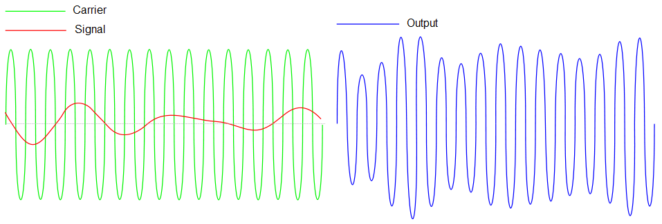

A basic AM radio transmitter works by first Direct Current (DC) -shifting the modulating signal, then multiplying it with the carrier wave using a frequency mixer. The output of this process is a signal with the same frequency as the carrier but with peaks and troughs that vary in proportion to the strength of the modulating signal. This is amplified and fed to an antenna. An AM receiver consists primarily of a tuneable filter and an envelope detector, which traces the peaks of the modulated signal to recover the modulating signal.

In its basic form, amplitude modulation produces a signal with power concentrated at the carrier frequency and in two adjacent sidebands. Each sideband is equal in bandwidth to that of the modulating signal and is a mirror image of the other. Thus, most of the power output by an AM transmitter is effectively wasted: half the power is concentrated at the carrier frequency, which carries no useful information (beyond the fact that a signal is present); the remaining power is split between two identical sidebands, only one of which is needed.

To increase transmitter efficiency, the carrier can be removed (suppressed) from the AM signal. This produces a reduced-carrier transmission or double-sideband suppressed carrier (DSSC) signal. If the carrier is only partially suppressed, a double-sideband reduced carrier (DSRC) signal results. DSSC and DSRC signals need their carrier to be regenerated (by a beat frequency oscillator, for instance) to be demodulated using conventional techniques.

Even greater efficiency is achieved—at the expense of increased transmitter and receiver complexity—by completely suppressing both the carrier and one of the sidebands. This is single-sideband modulation, widely used in amateur radio due to its efficient use of both power and bandwidth.

A simple form of AM often used for digital communications is on-off keying, a type of amplitude-shift keying by which binary data is represented as the presence or absence of a carrier wave. This is commonly used at radio frequencies to transmit Morse code, referred to as continuous wave (CW) operation

**Example - Full AM**

Consider the modulation of a simple sinusoidal wave on a sinusoidal carrier wave.

The equation for the carrier wave of frequency fc is: -

fc(t) = Vc.sin (2.π.fc.t)

and the modulating wave of frequency fm plus a DC shift is: -

fm(t) = Vdc + Vm.sin (2.π.fm.t)

The amplitude-modulated signal is the two waveforms multiplied together

fAM(t) = [Vdc + Vm.sin (2.π.fm.t)] . [Vc.sin (2.π.fc.t)]

fAM(t) = Vc.Vdc.sin(2.π.fc.t) + Vc.Vm.sin (2.π.fc.t).sin (2.π.fm.t)

*From the trigonometric identity* 2.sin A.sin B = cos (A - B) - cos (A + B)

fAM(t) = Vc.Vdc.sin (2.π.fc.t) + 0.5.Vc.Vm.cos (2.π.(fc - fm).t)) - 0.5.Vc.Vm.cos (2.π.(fc + fm).t)

|  |  |
| --- | --- |
| AM Two Sines Spectrum | Full AM Two Sines |
| The modulated signal consists of the carrier wave plus two sinusoidal waves known as sidebands. | The modulation index (m) is defined as the ratio of the modulation signal amplitude to the carrier amplitude. |

The table below shows both the time domain and frequency domain for a range of modulation indexes. Excessive distortion is produced when m is greater than 1

|  |  |  |
| --- | --- | --- |
| **Time Domain** | **Frequency Domain** | **Modulation Index** |
| m = 0 | m = 0 | m = 0.0 |
| m = 0.25 | m = 0.25 | m = 0.25 |
| m = 0.5 | m = 0.5 | m = 0.5 |
| m = 1.0 | m = 1.0 | m = 1.0 |
| m = 1.25 | m = 1.25 | m = 1.25 |
| m = 1.5 | m = 1.5 | m = 1.5 |

**Equipment Set Up**

Connect the output connector of the waveform generator to channel A of the Pico Scope.

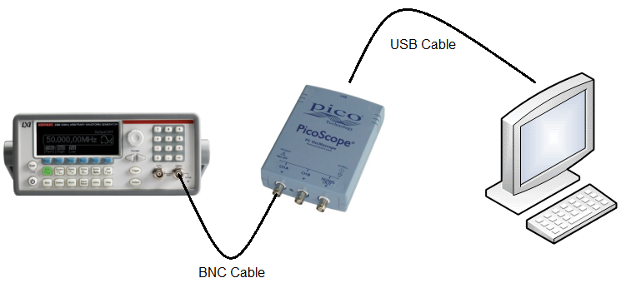

**Waveform Generator Set Up**

Press the Power Key.

* + - Press the Utility Key, Select Output Set Up, Select Hi-Z, Select Done
    - Press the Sine Key, Using the Numeric Keypad - set the frequency to 1 kHz. and Amplitude to 5 Vpp, Press the Output Key

**Pico Scope Set Up - Oscilloscope**

|  |  |
| --- | --- |
| Start the Pico Scope Software. Set Channel A to Auto and AC Coupling. Set the time base to 500 μs/div. | Set the trigger (bottom left of screen) to Auto. |
| Pico Scope Set Up | Pico Scope Set Up |

Once set correctly the following should be displayed.

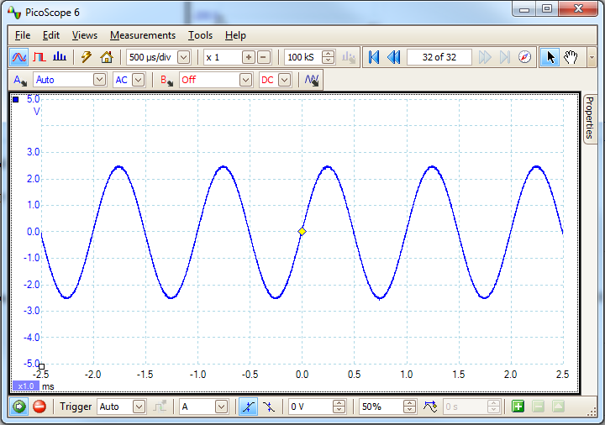

Using the Waveform Generator's Navigation Wheel, observe the effect of changing the Frequency and Amplitude of the waveform.

Re-set the Waveform Generator to output a sinusoidal signal of frequency 1 kHz. and Amplitude to 5 Vpp.

**Pico Scope Set Up - Spectrum Analyser**

|  |  |  |
| --- | --- | --- |
| Change the Pico Scope to Spectrum mode by clicking the bar graph icon, (highlighted in blue on the graphic shown). Set Channel A to Auto and AC Coupling. Set the Spectrum display to 48.83 kHz. | Set the trigger (bottom left of screen) to Auto. | Select Spectrum Options. Window Function Gaussian, Scale Linear, Click Apply, Click OK. |
| Pico Scope Set Up 3 | Pico Set Up | Spectrum Options |

Once set correctly the following should be displayed.

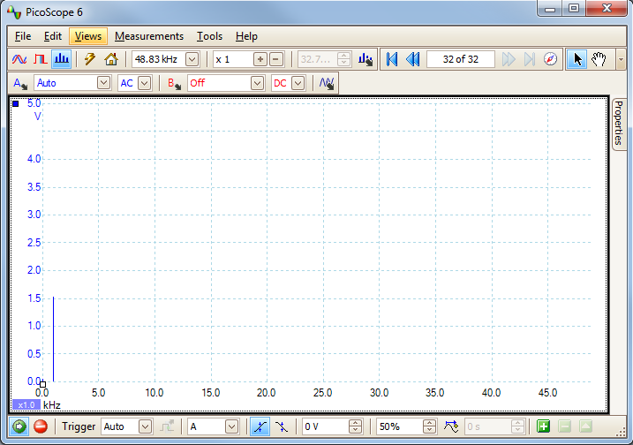

Familiarise, yourself with the equipment, by repeating the above procedure for Square, Ramp and Noise Waveforms.

**AM Transmission - Waveform Generator Set Up**

Press the Power Key.

* + - Press the Utility Key, Select Output Set Up, Select Hi-Z, Select Done
    - Press the Sine Key, Using the Numeric Keypad - set the frequency to 20 kHz. and Amplitude to 3.5 Vpp.
    - Press the Mod Key, Set Type to AM, Src to Int, Set AM Depth to 40%, Set AM Freq to 1 kHz, Set Shape to Sine. Press the Output Key

**AM Transmission - Pico Scope Set Up**

* + - For use as an Oscilloscope. Set Channel A to Auto and AC Coupling. Set the time base to 500 μs/div. Set the trigger to Auto
    - For use a Spectrum Analyser. Set Channel A to Auto and AC Coupling. Set the Spectrum display to 48.83 kHz. Set the trigger (bottom left of screen) to Auto. Select Spectrum Options. Window Function Gaussian, Scale Linear, Click Apply, Click OK.

Once set correctly the following should be displayed.

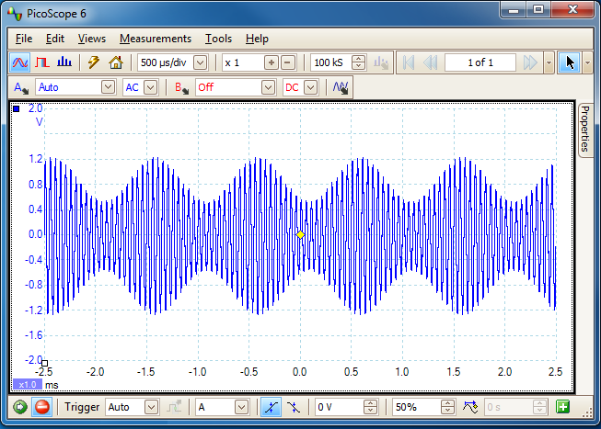

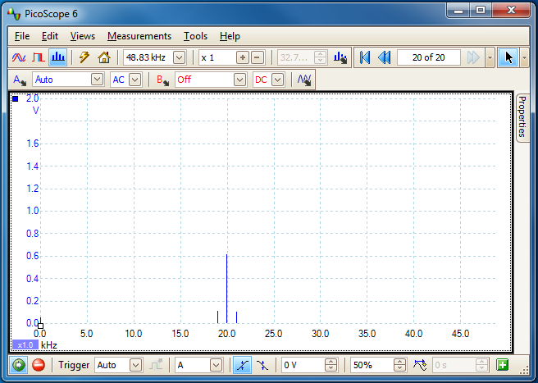

Vary the frequency of the modulator frequency (i.e. the 1 kHz signal, not the 20 kHz signal) and observe the effect.

Complete the graphs in the following table and identify a transmission bandwidth, stating why you choose this figure. (The Waveform generator set up instructions are below the table)

|  |  |  |  |
| --- | --- | --- | --- |
| **Signal** | **Time Domain** | **Frequency Domain** | **Transmission Bandwidth** |
| Sine | http://staffweb.cms.gre.ac.uk/~sp02/Signals&Modulation/images/BlankAM.png | http://staffweb.cms.gre.ac.uk/~sp02/Signals&Modulation/images/BlankAMSpectrum.png |  |
| Square - This represents Data. | http://staffweb.cms.gre.ac.uk/~sp02/Signals&Modulation/images/BlankAM.png | http://staffweb.cms.gre.ac.uk/~sp02/Signals&Modulation/images/BlankAMSpectrum.png |  |
| Audio -  [How You Remind Me](http://staffweb.cms.gre.ac.uk/~sp02/Signals&Modulation/AudioFiles/Telephone/Nickelback%20-%20How%20You%20Remind%20Me%20-%20POTS.wav) | http://staffweb.cms.gre.ac.uk/~sp02/Signals&Modulation/images/BlankAM.png | http://staffweb.cms.gre.ac.uk/~sp02/Signals&Modulation/images/BlankAMSpectrum.png |  |

**Waveform Set Up Instructions**

|  |  |  |
| --- | --- | --- |
| **Sine** | **Square** | **Audio** |
| * + - Press the Utility Key, Select Output Set Up, Select Hi-Z, Select Done     - Press the Sine Key, Using the Numeric Keypad - set the frequency to 20 kHz. and Amplitude to 3.5 Vpp.     - Press the Mod Key, Set Type to AM, Src to Int, Set AM Depth to 40%, Set AM Freq to 4 kHz, Set Shape to Sine. Press the Output Key | * + - Press the Utility Key, Select Output Set Up, Select Hi-Z, Select Done     - Press the Square Key, Using the Numeric Keypad - set the frequency to 20 kHz. and Amplitude to 3.5 Vpp.     - Press the Mod Key, Set Type to AM, Src to Int, Set AM Depth to 60%, Set AM Freq to 1 kHz, Set Shape to Squr. Press the Output Key | * + - Press the Utility Key, Select Output Set Up, Select Hi-Z, Select Done     - Press the Sine Key, Using the Numeric Keypad - set the frequency to 20 kHz. and Amplitude to 3.5 Vpp.     - Press the Mod Key, Set Type to AM, Src to Ext, Set AM Depth to 95%, Press the Output Key   To play the audio track - [How You Remind Me](http://staffweb.cms.gre.ac.uk/~sp02/Signals&Modulation/AudioFiles/Telephone/Nickelback%20-%20How%20You%20Remind%20Me%20-%20POTS.wav) - connect the output of the soundcard - green socket - via the 3.5 mm to BNC Audio cable to the Modulation in Connector on the rear of the Waveform Generator. Ensure that the volume levels are set to maximum in both the media player and, task bar speaker control.  To view the spectrum more clearly, use the zoom control - Zoom Control. |

**Sinusoidal Signal  Demodulation**

Using two BNC to probe clip leads and a BNC T piece, connect the equipment in the following configuration. Connect the two  probe clip's black crocodile clips to each other; and connect the diode between the two red signal connectors of probes clips. Note it does not matter which way round the diode is connected.

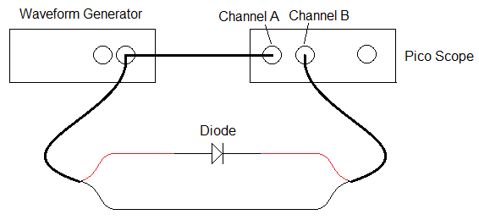

Set the Waveform Generator to produce a Amplitude Modulation Sinusoidal wave with the following settings:-

* + - Press the Utility Key, Select Output Set Up, Select Hi-Z, Select Done
    - Press the Sine Key, Using the Numeric Keypad - set the frequency to 20 kHz. and Amplitude to 20 Vpp.
    - Press the Mod Key, Set Type to AM, Src to Int, Set AM Depth to 40%, Set AM Freq to 1 kHz, Set Shape to Sine. Press the Output Key

To use the Pico Scope as an Oscilloscope use the following settings: *Note the Channel B is set to DC coupling.

* + - Set Channel A to Auto and AC Coupling. Set the time base to 500 μs/div. Set the trigger to Auto
    - Set Channel B to Auto and **DC** Coupling.

To use the Pico Scope as a Spectrum Analyser use the following settings: *Note the Channel B is set to AC coupling.

* + - Set Channel A to Auto and AC Coupling. Set Channel A to Auto and AC Coupling. Set the Spectrum display to 48.83 kHz. Set the trigger (bottom left of screen) to Auto. Select Spectrum Options. Window Function Gaussian, Scale Linear, Click Apply, Click OK.
    - Set Channel B to Auto and **AC** Coupling.

Change the diode in both directions, and complete the graphs in the following table

|  |  |  |
| --- | --- | --- |
| **Diode Direction** | .Diode | .Diode |
| **Time Domain** | http://staffweb.cms.gre.ac.uk/~sp02/Signals&Modulation/images/BlankAM.png | http://staffweb.cms.gre.ac.uk/~sp02/Signals&Modulation/images/BlankAM.png |
| **Frequency Domain** | http://staffweb.cms.gre.ac.uk/~sp02/Signals&Modulation/images/BlankAMSpectrum.png | http://staffweb.cms.gre.ac.uk/~sp02/Signals&Modulation/images/BlankAMSpectrum.png |

**Audio Signal Demodulation**

To play the audio track - [How You Remind Me](http://staffweb.cms.gre.ac.uk/~sp02/Signals&Modulation/AudioFiles/Telephone/Nickelback%20-%20How%20You%20Remind%20Me%20-%20POTS.wav) - connect the output of the soundcard - green socket - via the 3.5 mm audio plug to BNC cable to the Modulation in Connector on the rear of the Waveform Generator. Ensure that the volume levels are set to maximum in both the media player and, task bar speaker control.

Waveform Generator Set Up

* + - Press the Utility Key, Select Output Set Up, Select Load – set the load to 8 Ω, Select Done
    - Press the Sine Key, set the frequency to 50 kHz. Adjust the amplitude to 2.759 Vpp.
    - Press the Mod Key, Set Type to AM, Src to Ext, Set AM Depth to 95%, Press the Output Key

Connect the equipment as shown: Try with the diode in both directions and with no diode.

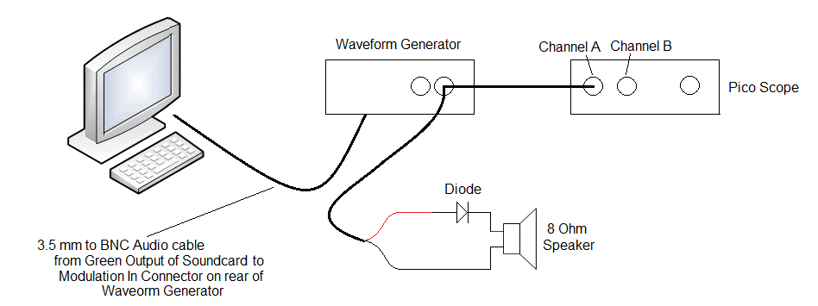

**Radio Spectrum**

Connect one end of the 7 meter length of wire to connect to channel A of the Pico Scope via the red signal connector of the BNC to probe clip cable. Preferably the wire will need to be hung out the window, however it can be used inside as long as the wire is reasonably straight. Try to avoid the wire becoming too close to computers as they generate electromagnetic radiation which will swamp the signals you are looking for.

View the signal in the spectrum analyser. Initially Set the Spectrum Analyser such that :- Channel A to Auto and AC Coupling. Set the Spectrum display to 1.563 MHz Set the trigger to Auto. Select Spectrum Options. Window Function Gaussian, Scale Linear, Click Apply, Click OK.

You should see a a number of radio signals, use the zoom control to view the individual signal spectrums more clearly. Open up the spectrum to 12 MHz, and then 25 MHz to view other sections of the spectrum. Try and identify what the source of transmissions are. A good place to start is the [United Kingdom Frequency Allocation Table](http://staffweb.cms.gre.ac.uk/~sp02/wireless/ukfat08.pdf)

Identify three or four signals across the spectrum, complete the table below, and include a plot of the spectrum identifying these signals in  in your report.

|  |  |
| --- | --- |
| **Carrier Frequency** | **Transmission Identify** |
|  |  |
|  |  |
|  |  |
|  |  |

To select a radio station to listen to, the antenna must be tuned to the station's carrier frequency using a tuned circuit. A tuned circuit consists of a coil of wire and a capacitor. The particular radio frequency a tuned circuit selects depends, on the number of turns of wire on the coil, and the value of the capacitor.

Wind three or four turns of paper around the ferrite rod and tape secure, ensure that the rod can slide in and out of the paper tube. Wind the one metre length of wire around the tube, leaving 5cm of wire at each end of the coil.

The coil is constructed using a ferrite rod. It is not necessary to use a ferrite rod to construct the coil, however the rod has the effect of increasing the magnetic filed within the coil, and this reduces the number of turns required.

|  |  |
| --- | --- |
| Using a small piece of terminal block, construct the circuit shown. Connect the red signal connector of the BNC to probe clip to point A, and the  Black crocodile clip to point E | Tuned Circuit |

View the signal in the spectrum analyser. Initially Set the Spectrum Analyser such that :- Channel A to Auto and AC Coupling. Set the Spectrum display to 1.563 MHz Set the trigger to Auto. Select Spectrum Options. Window Function Gaussian, Scale Linear, Click Apply, Click OK.

Vary the tuning of the circuit by moving the ferrite rod in and out of the coil. Observe the effect on the spectrum and include a plot of a spectrum in your report which illustrates the tuning effect of the circuit.  Use the zoom control to view the individual signal spectrums more clearly.

1. **Reflection**

Identify the sections of the laboratory you have understood and demonstrate your understanding - beyond the simple level of completing the laboratory - through cognitive processes such as analysing, explaining, interpreting, and evaluating. Illustrate, by the use of examples how the laboratory contributed towards your understanding and your Degree programme.

For the sections of the laboratory in which you struggled with, or were uncertain of, identify why this was the case. Evaluate the effectiveness of your learning strategy, including factors such as, motivation, preparation, commitment, time management, communication, constraints and support. With reflection to past experience, identify how you could improve your learning and performance to overcome the barriers encountered in this laboratory such that they do not infringe upon the next laboratory you undertake.

With relation to the sections of the laboratory you encountered difficulty with, state how, and by when you intend to gain competence in these areas.

Critically appraise the laboratory; identify sections you thought were positive, facilitated your understanding and contributed to your Degree programme; identify sections that require improvement and state how and why would you change the laboratory to improve the laboratory for the next year's students.

1. **Optional**
   * **Other Modulations**

In addition to AM the Waveform Generator is capable of producing other modulations schemes.

* + - Frequency Modulation (FM)
    - Phase Modulation (PM)
    - Frequency Shift Keying (FSK)

Repeat the Modulation section of the laboratory using the other modulation schemes.

* + **Radio Scanner**

 If you wish to explore sections of the radio spectrum you are unfamiliar with, the school has a small number of IC-R20 Icom Scanning Wideband Receivers, which you are welcome to borrow.

[IC-R20 Icom](http://staffweb.cms.gre.ac.uk/~sp02/equipment/datasheets/IC-R201Leaflet.pdf) Scanning Wideband Receiver

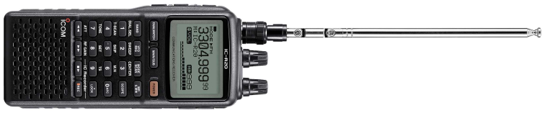

Frequency coverage 0.15 MHz - 3305 MHz * FM, WFM, AM, USB, LSB, CW * Tuning steps 0.01 kHz, 0.1 kHz, 5 kHz, 6.25 kHz, 8.33 kHz, 9 kHz, 10 kHz, 12.5 kHz, 15 kHz, 20 kHz, 25 kHz, 30 kHz, 50 kHz, 100 kHz * 1250 alphanumeric memories * Scanning speed 100 channels/second * Multiple scan modes * Dual watch * Band scope (bandwidth 1 - 100 kHz) * CTCSS & DTCS tone squelch function * Built-in 32 MB IC recorder * CI-V compatibility * Built-in ferrite bar antenna for AM * Built-in attenuator & RF control * Auto Frequency kHz Control (AFC) * Noise blanker & Auto Noise Limiter * Voice Squelch Control (VSC) * 120mW audio (8 Ohms)

[ICOM IC-R20 Manual](http://staffweb.cms.gre.ac.uk/~sp02/equipment/datasheets/IC-R20manual.pdf)

* + **Crystal Radio**

With the addition of a few more components, the tuned circuit used the laboratory can be adapted to build a crystal radio. Crystal radios require no battery, and do not have any internal oscillators - which are used in all other radio receivers - these internal oscillators can be detected by the radio frequencies they emit, and hence determine location. This same principal is used by the BBC to detect if a television is being watched without a licence.

The antenna should be as high and as long as possible - about 30 metres should be sufficient - and insulated at each end. The insulators can be made from a piece of PVC, such as a 5 cm length of drainage pipe. The ground connection should be made by connecting to a metal rod which has been driven at least 70 cm into the ground.

For further information visit the [Crystal Radio Society](http://www.midnightscience.com/)

Do not use the system near high voltage transmission lines, or when there is a probability of lightning.  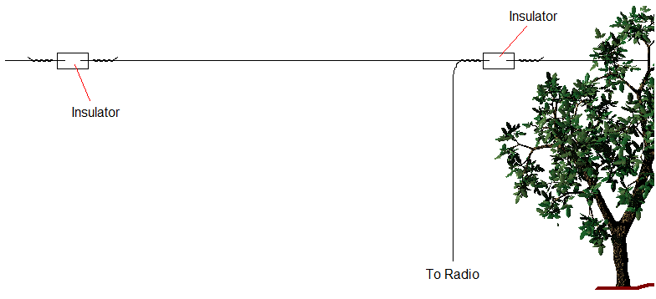

* + **Become a Radio Amateur**

Radio amateurs use a wide variety of radio communications equipment to communicate with each other and are often involved with the design of cutting-edge experimental wireless technology. The term amateur denotes the fact that amateur radio operators do not operate for profit or commercial gain. There are approximately six million radio amateurs world wide. The Amateur radio community has exclusive global access to access to large areas of the radio spectrum. For More information contact the Radio Society of Great Britain ([RSGB](http://www.rsgb.org/))

**Amateur Radio Frequency Bands**

|  |  |  |
| --- | --- | --- |
| **Frequency Spectrum** | **Band Name** | **Frequency Range** |
| Low Frequency (LF) | 136 kHz (2200 metres) | 135.7 kHz - 137.8 kHz |
| Medium Frequency (MF) | 500 kHz (600 metres) | 501 kHz - 504 kHz |
| Medium Frequency (MF) | 1.8 MHz (160 metres) | 1.810 MHz - 2.000 MHz |
| High Frequency (HF) | 3.5 MHz (80 metres) | 3.500 MHz - 4.000 MHz |
| High Frequency (HF) | 5 MHz (60 metres) | 5.100 MHz - 5.400 MHz |
| High Frequency (HF) | 7 MHz (40 metres) | 7.000 MHz - 7.300 MHz |
| High Frequency (HF) | 10 MHz (30 metres) | 10.10 MHz - 10.15 MHz |
| High Frequency (HF) | 14 MHz (20 metres) | 14.00 MHz - 14.35 MHz |
| High Frequency (HF) | 18 MHz (17 metres) | 18.068 MHz - 18.168 MHz |
| High Frequency (HF) | 21 MHz (15 metres) | 21.00 MHz - 21.45 MHz |
| High Frequency (HF) | 24 MHz (12 metres) | 24.89 MHz - 24.99 MHz |
| High Frequency (HF) | 28 MHz (10 metres) | 28.00 MHz - 29.70 MHz |
| Very High Frequency (VHF) | 50 MHz (6 meters) | 50.00 MHz - 54.00 MHz |
| Very High Frequency (VHF) | 70 MHz (4 metres) | 70.00 MHz - 70.50 MHz |
| Very High Frequency (VHF) | 144 MHz (2 meters) | 144.0 MHz - 148.0 MHz |
| Very High Frequency (VHF) | 21 MHz (1.25 metres) | 219.0 MHz - 225.0 MHz |
| Ultra High Frequency (UHF) | 430 MHz (70 cm) | 420.0 MHz - 450 MHz |
| Ultra High Frequency (UHF) | 900 MHz (33 cm) | 902.0 MHz - 928.0 MHz |
| Ultra High Frequency (UHF) | 1.3 GHz (23 cm) | 1.24 GHz - 1.3 GHz |
| Ultra High Frequency (UHF) | 2.3 GHz (13 cm) | 2.30 GHz - 2.31 GHz |
| Super High Frequency (SHF) | 3.4 GHz (9cm) | 3.3 GHz - 3.5 GHz |
| Super High Frequency (SHF) | 5.7 GHz (6 cm) | 5.650 GHz - 5.925 GHz |
| Super High Frequency (SHF) | 10 GHz (3 cm) | 10.0 GHz - 10.5 GHz |
| Super High Frequency (SHF) | 24 GHz (12 mm) | 24 GHz - 24.25 GHz |
| Extremely High Frequency (EHF) | 47 GHz (6 mm) | 47.0 GHz - 47.2 GHz |
| Extremely High Frequency (EHF) | 80 GHz (4 mm) | 75.5 GHz - 81.0 GHz |
| Extremely High Frequency (EHF) | 120 GHz (2.5 mm) | 119.98 GHz - 120.02 GHz |
| Extremely High Frequency (EHF) | 145 GHz (2 mm) | 142 GHz - 149 GHz |
| Extremely High Frequency (EHF) | 245 GHz (1 mm) | 241 GHz - 250 GHz |

1. **Appendices**
   * Fast Fourier Transform (FFT). A FFT is an algorithm to compute the Discrete Fourier Transform (DFT). The DFT transforms discrete functions between the time and frequency domains.
   * FFT Windows. Spectrum Analysers capture a block of sampled data over a finite time interval and then uses a Fast Fourier Transform (FFT) to compute its spectrum. The algorithm assumes a signal level of zero at all times outside the captured time interval. Typically, this assumption causes sharp transitions to zero at either end of the data, and these transitions have an effect on the computed spectrum, creating unwanted artefacts such as ripple and gain errors. To reduce these artefacts, the signal can be faded in and out at the start and end of the block. There are several commonly used fading profiles, called window functions, that can be chosen according to the type of signal and the purpose of the measurement. The Window Functions control in the Spectrum Options dialog enables the selection one of the standard window functions for spectrum analysis. The following table shows some of the figures of merit used to assess the functions.

|  |  |  |  |  |
| --- | --- | --- | --- | --- |
| **Window** | **Main peak width (bins @ -3 dB)** | **Highest side lobe (dB)** | **Side lobe Roll-Off (dB/Octave)** | **Notes** |
| Blackman | 1.68 | -58 | 18 | Often used for audio work |
| Gaussian | 1.33 to 1.79 | -42 to -69 | 6 | Gives minimal time and frequency errors |
| Triangular | 1.28 | -27 | 12 | Also called Bartlett window |
| Hamming | 1.30 | -41.9 | 6 | Also called raised sine-squared; used in speech analysis |
| Hanning | 1.20 to 1.86 | -23 to -47 | 12 to 30 | Also called sine-squared; used for audio and vibration |
| Blackman-Harris | 1.90 | -92 | 6 | General purpose |
| Flat-top | 2.94 | -44 | 6 | Negligible pass-band ripple; used mainly for calibration |
| Rectangular | 0.89 | -13.2 | 6 | No fading; maximal sharpness; used for short transients |

* + Keithley 3390 50 MHz Arbitrary Waveform Generator
    - [Data Sheet](http://staffweb.cms.gre.ac.uk/~sp02/equipment/datasheets/3390_DataSht%5b1%5d.pdf)
    - [Manual](http://staffweb.cms.gre.ac.uk/~sp02/equipment/datasheets/3390-900-01%20(C%20-%20Jan%202009)(User)%5b1%5d.pdf)

|  |  |  |  |  |  |  |  |  |  |  |  |  |  |  |  |  |  |  |  |  |  |  |  |  |  |  |  |  |  |  |  |  |  |
| --- | --- | --- | --- | --- | --- | --- | --- | --- | --- | --- | --- | --- | --- | --- | --- | --- | --- | --- | --- | --- | --- | --- | --- | --- | --- | --- | --- | --- | --- | --- | --- | --- | --- |
| Keithley 3390 Front | |  |  | | --- | --- | | 1 | Power Key | | 2 | Graph / Local key | | 3 | Menu Operation Keys | | 4 | Display | | 5 | Navigation Wheel | | 6 | Cursor Keys | | 7 | Numeric Keypad | | 8 | Output Connector | | 9 | Sync Output Connector | | 10 | Trigger Key | | 11 | Output Key | | 12 | Help Menu Key | | 13 | Utility Menu Key | | 14 | Store / Recall Menu Key | | 15 | Modulation, Sweep and Burst Keys | | 16 | Waveform Selection Keys | |
| Rear Panel | |  |  | | --- | --- | | 1,2 | 10 MHz In / Out Connectors | | 3 | Power Connector | | 4,5,6 | GPIB, USB, and LAN Ports | | 7 | Trigger In/Out, FSK/Burst Connector | | 8 | Modulation in Connector | | 9 | TTL output | |

[Technician's Guide](http://staffweb.cms.gre.ac.uk/~sp02/Signals&Modulation/TechniciansGuide.html)